|  |  |
| --- | --- |
| Student ID | IT23245860 |
| Batch | WD.02.01 |
| **Marking Guide** | |
| App Logo and Launch Screen | **1** |
| User Onboarding Screens | **2** |
| Main Interface Design | **3** |
| Prototype Interaction | **2** |
| Design Aesthetics and Usability | **2** |
| **Total Marks** | **10** |
| Evaluator |  |

**Description:**

**SMARTWALLET** is a mobile application that helps users manage their money better by tracking expenses, setting savings goals, and making smarter financial decisions. It offers features like real-time expense tracking, goal-based savings and AI-driven investment recommendations. The app provides insights into spending habits and personalized suggestions to improve financial well-being. It is designed to tackle common financial challenges like overspending, lack of savings, and confusion about investing. This app aims to provide a simple and accessible way to manage personal finances, helping users develop better money habits and achieve financial stability.

**Target Audience:**

* Young professionals managing their income and expenses.
* College students learning financial responsibility.
* Families looking for better budgeting strategies.
* Small business owners tracking expenses efficiently.
* Anyone seeking to improve financial literacy and savings habits.

**Why it is Necessary:**

Many people struggle with managing their finances effectively due to a lack of budgeting knowledge, impulsive spending, or insufficient savings. **SmartWallet** bridges this gap by offering a user-friendly platform that not only tracks expenses but also educates users on smart financial decisions.

**Screenshots:**

**App logo:**

**Launch screen:**



**Onboarding Screens:**

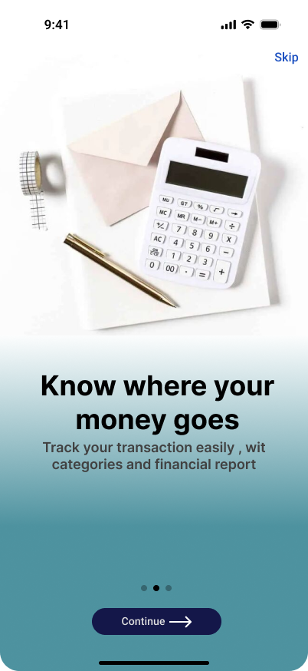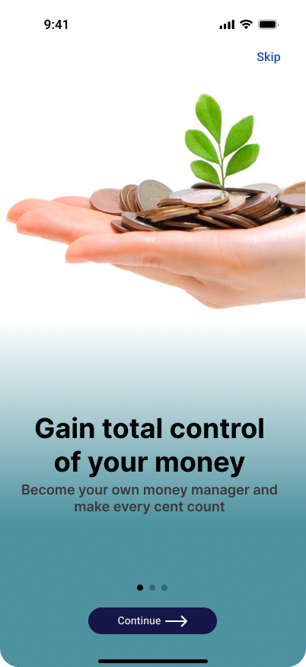

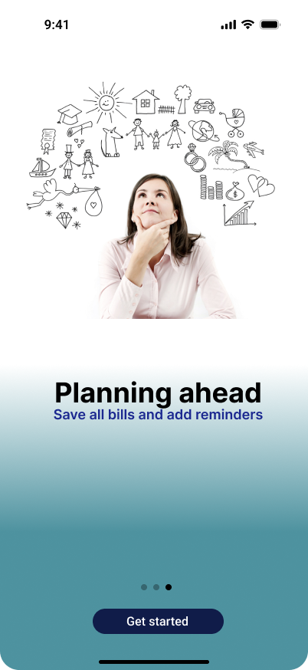

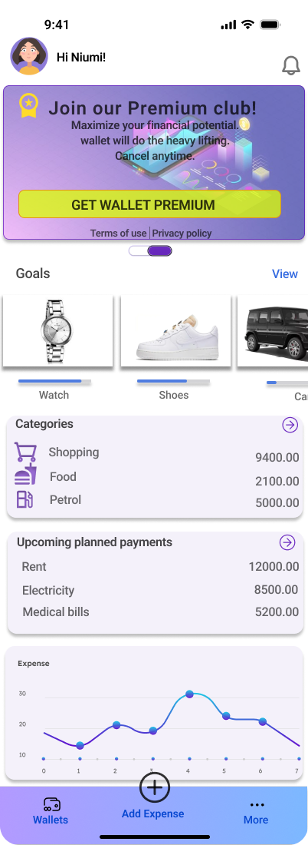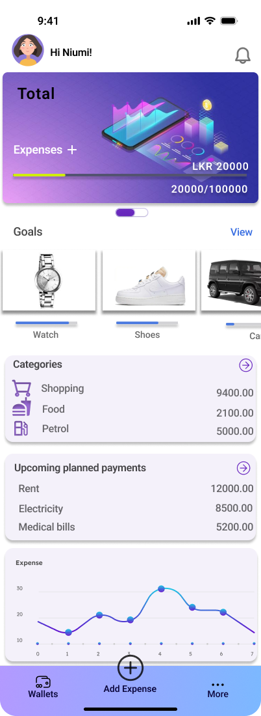**Main screens**

**Home:Welcome:**

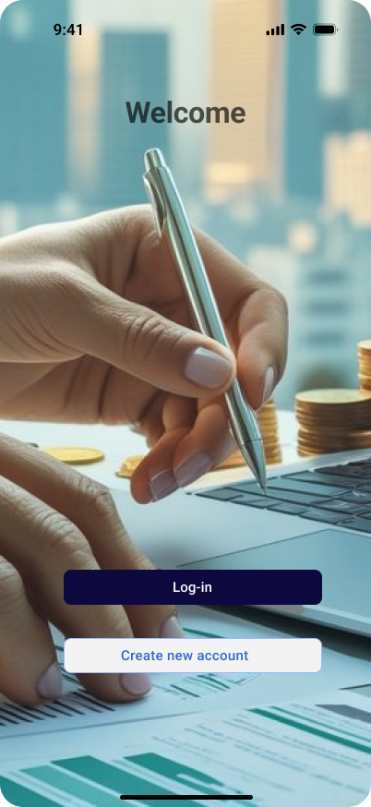

**Login:**

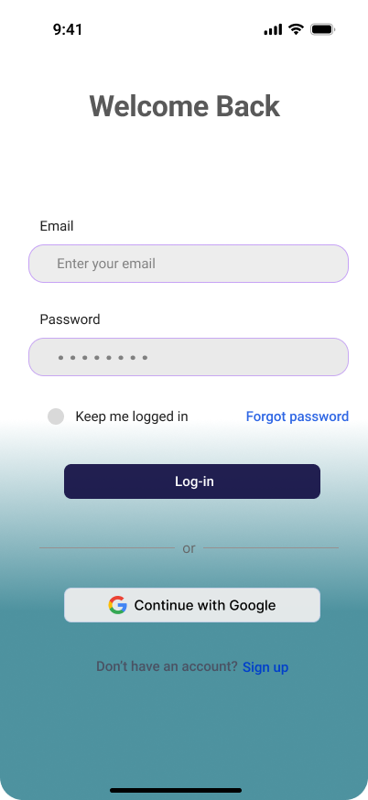

**Sign up**

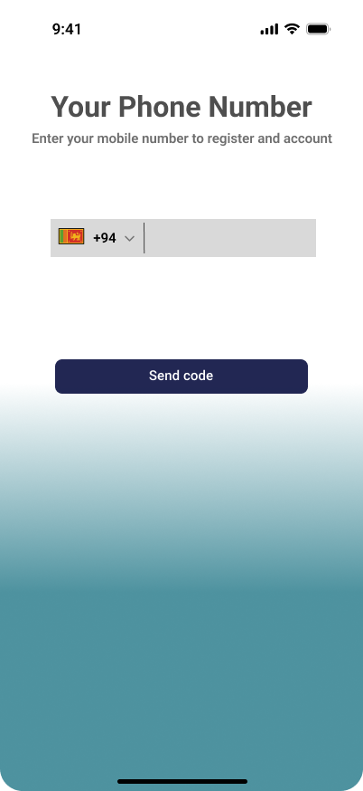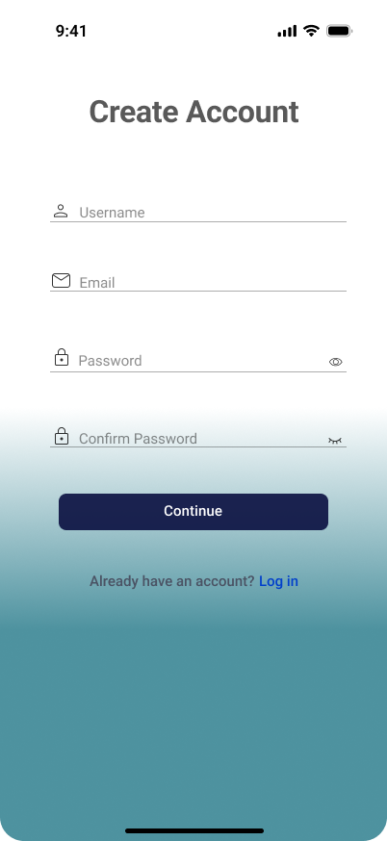

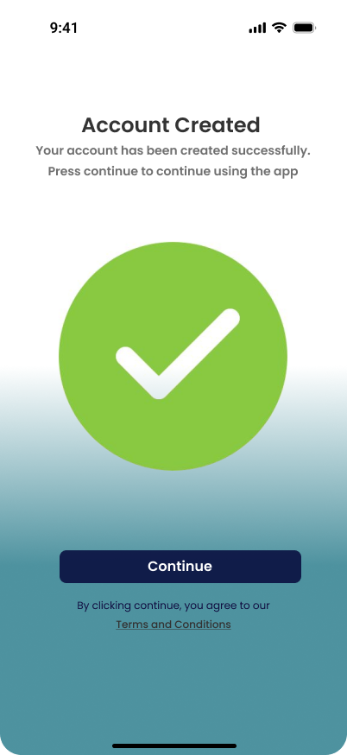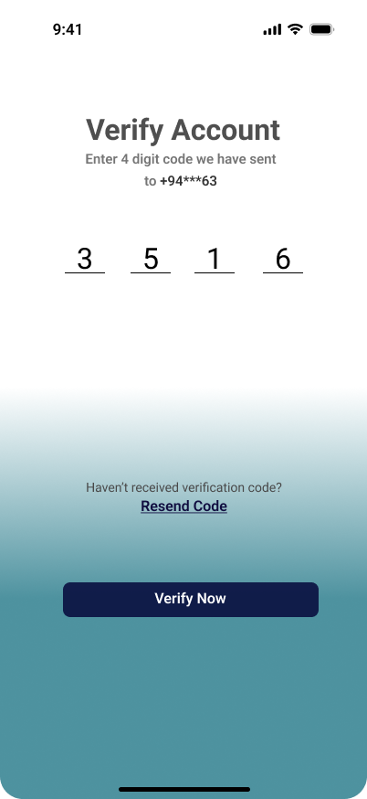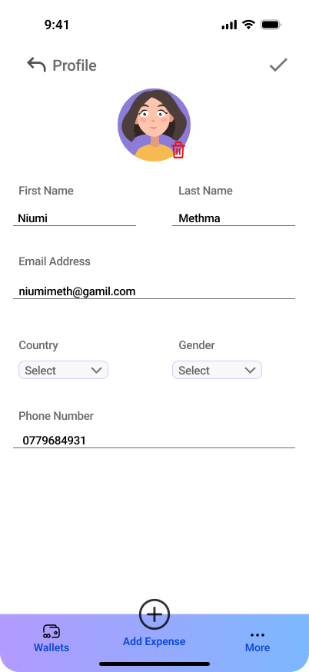**Profile:**

**Expenses:**

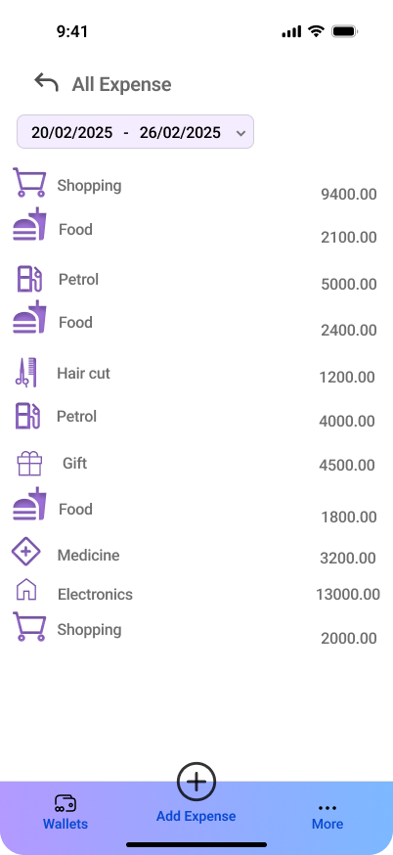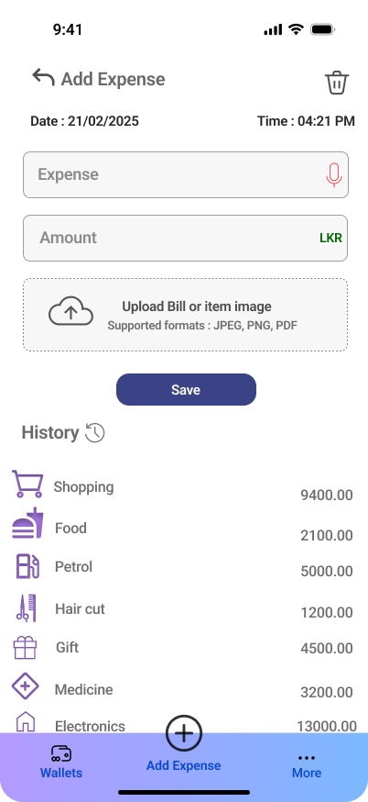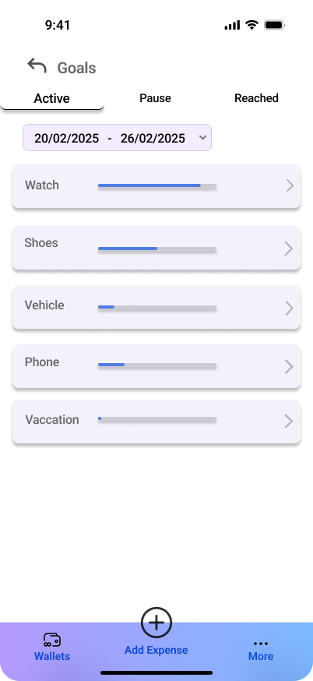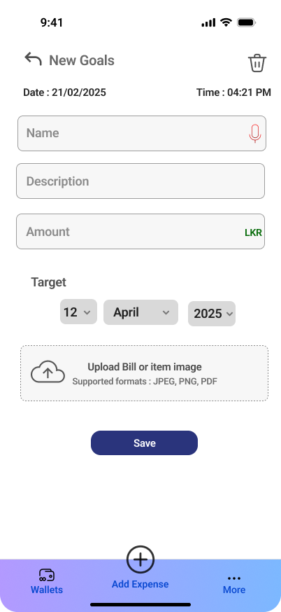**Goals:**

**Upcoming payments:**

**Preferences:**

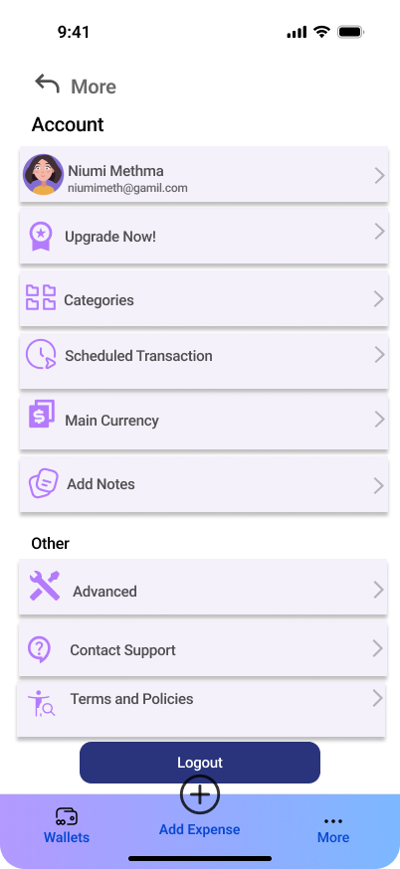

**Premium:**

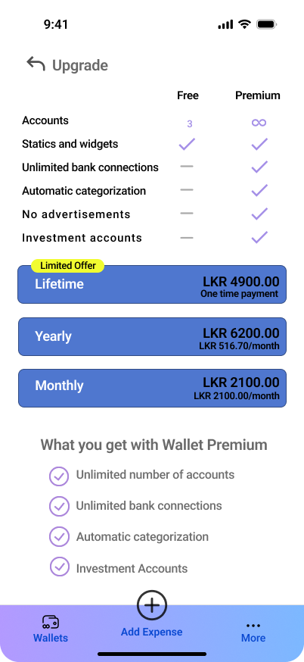

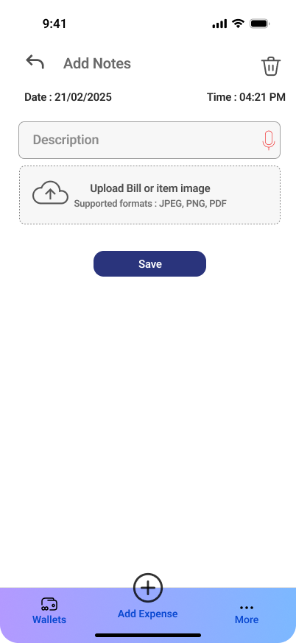**Notes:**

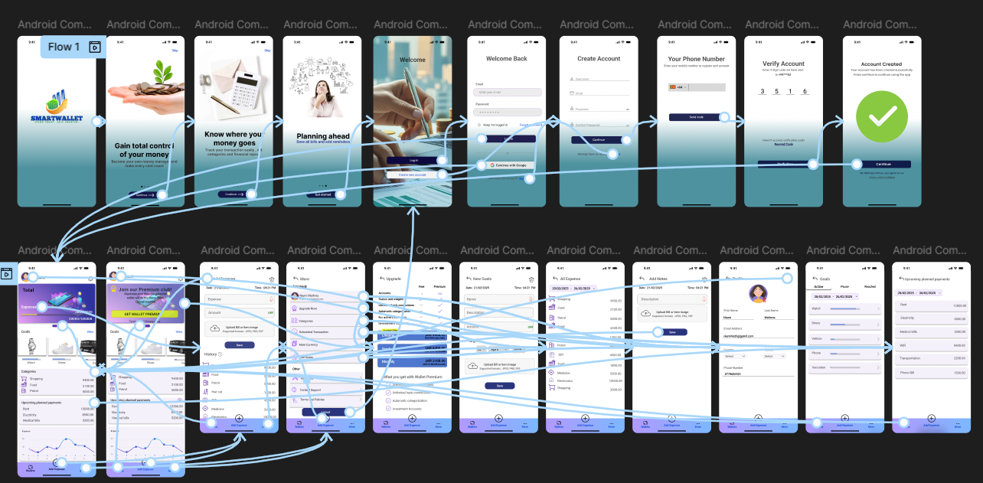**Prototype:**